Curriculum Vitae - Khalid A. Al-Dolaimy

Objective

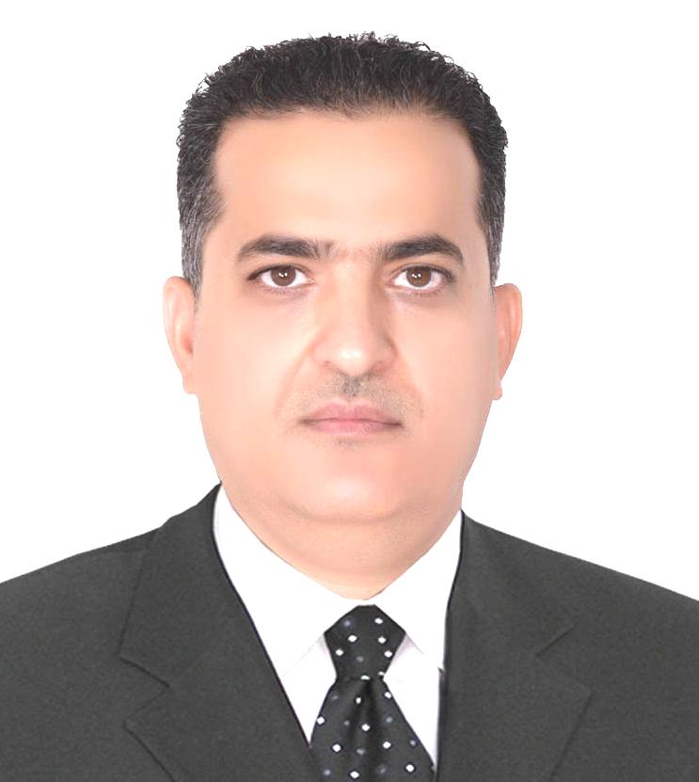
To exhibit my skills and expertise of my career as Mechanical Designer/Engineer, and as lecturer of mechanical engineering subjects at the engineering universities and colleges

.
Personal Information

Academic degree: Lecturer
Website: www.uodiyala.edu.iq
License: Provisional Engineering license / Ontario - Canada
Professional Profile and Skills

- Efficient in lecturing mechanical engineering subjects at the engineering universities and colleges

- Experienced in hole steel factories & machines design, and processes engineering

- Expertise in Robotics & CNC programming using CAD CAM Systems

- Excellent in quality control techniques and knowledge of ISO standard and others

- Accurate in 3D mechanical design & drafting, Auto CAD drafting and design, design calculations, optimum dimensioning of parts according to the loading analysis and strength of materials

- Organized in engineering documentation, quantity estimating, and pricing

- Strong experience in mechanical machines trouble shooting and maintenance

- Computer skills: AutoCAD, Master CAM X, Solid Works, DNC Max, Robot Master, and MS Office
Educational Qualifications & Training Courses

- M. Sc. Mechanical Engineering discipline / Production Engineering 1994

University of Technology, Baghdad

- B.Sc. Mechanical Engineering discipline / Production Engineering 1988

University of Technology, Baghdad

International Certificate Assessments

- University of Toronto / Canada - (M. Sc.) certificates assessment
Examined and Approved - Equivalent to 2 years Master’s Degree at Canadian engineering universities

- University of Toronto / Canada (B. Sc.) certificates assessment

Examined and Approved - Equivalent to 4 years Bachelor’s Degree at Canadian engineering universities

Training Courses

- Material selection / CES Edu Pack Software/ Diyala University /Iraq 2017

- Computer and Microsoft Windows / Diyala University /Iraq 2013

- Methods of Teaching / Diyala University /Iraq 2013

- Fundamental of project Management / Sheridan College / Canada 2012

- MasterCAM Mill, Wire cutting and multi axis / In-House Solution Inc. / Canada 2008

- SolidWorks I & II Courses / George Brown College / Canada 2007
Memberships

- Professional Engineers Ontario-PEO / Canada / Provisional Engineering 2011 till now

- Member of Iraqi Engineers Union 1988 till now
Employment History Note: for abbreviation, only the employment
after 2006 is mentioned on this CV

University of Diyala / Diyala - Iraq 2013-Till now

Position: Lecturer at the Chemical Engineering Department.

Description: Teaching; CAD - SolidWorks, Statics, Strength of Materials, and Engineering Drafting

CCR Technologies Inc. / Hamilton - Canada 2011 – 2012

Position: Mechanical designer

Description:

CCR Technologies Inc. specializes in designing and manufacturing of continuous steel casting consist of a heavy equipment, machines and whole steel mill factories.

Duties:

- Designed; heavy equipment of steel mill factories and steel structure of 3 story
- Prepared engineering calculations of the designs
- Worked on 3D and 2D detailed drawings
- Prepared Bill of Materials of the designed equipment and steels for the purchase department

ISA Technologies Inc. / Mississauga - Canada 2006 – 2008

ISA Technologies Inc. specializes in designing and manufacturing of plastic- fume injection machine and all the related auxiliary equipment such as products automatic manipulation, automatic testing and packaging.

Position: Project Engineer - Mechanical Engineering Designer

Duties:

- Managed all project aspects, production and constructions
- Prepared plans for production
- Prepared transmittal & submittal documents
- communicated with the customers and venders
- Contributed in developing designs of the machines and equipment on SolidWorks

Published Research Papers

No | Title of research | Journal name | Publisher | ISSN
1 | Effect Of Resistance Spot Welding Parameters For Steel Sheets On The Welding Strength | Diyala Journal  of Engineering Sciences | Second Engineering Scientific Conference  College of Engineering –University of Diyala  16-17 December. 2015, pp. 668-673 | ISSN 1999-8716
2 | Effect of Cutting Parameters on Surface Roughness in Turning Operations | journal of Al-Qadisiyah for pure science | journal of Al-Qadisiyah for pure science

Conferences

No | Conference | Paper title | Proceeding or journal name | No
1 | Second Conference of the Engineering College University of Diyala 2015-2016 | Effect Of Resistance Spot Welding Parameters For Steel Sheets On The Welding Strength | Diyala Journal  of Engineering Sciences | ISSN 1999-8716

